The partners
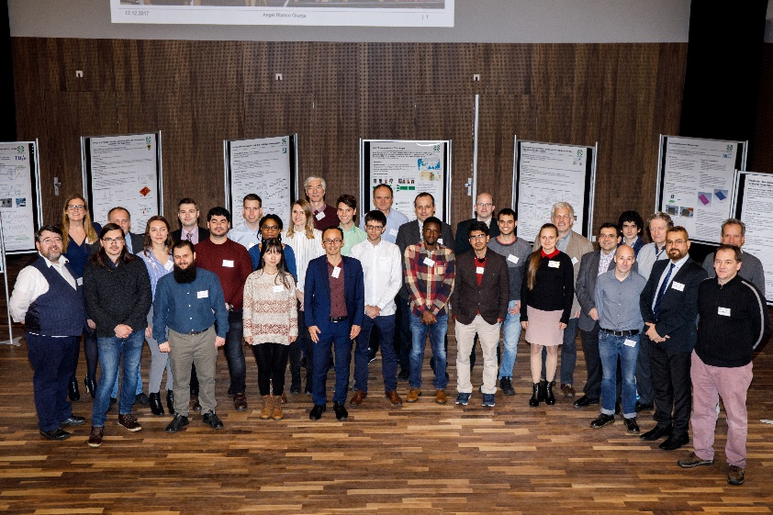
Contact

Coordinator ITN CELTA Project:

Idelfonso Tafur Monroy - TU/e

i.tafur.monroy@tue.nl

Training Coordinator:

Andreas Penirschke - THM/TuDa

andreas.penirschke@iem.thm.de
Research Coordinator:

Viktor Krozer - GUF

krozer@physik.uni-frankfurt.de

Commercial Exploitation Coordinator:

Pablo Acedo - UC3M

pag@ing.uc3m.es

Recruitment and Equal Opportunities Coordinator:

Raida Zbynek - BUT

raida@feec.vutbr.cz

Secondment Coordinator:
Giorgio Leuzzi - AQ

giorgio.leuzzi@univaq.it

Project Assistant:

Femke Witteveen - TU/e

e.a.witteveen@tue.nl

Convergence of Electronics and Photonics Technologies for Enabling Terahertz
Applications
www.celta-itn.eu
This project has received funding from the European Union’s Horizon 2020 research and innovation programme under the Marie Sklodowska-Curie grant agreement No. 675683.
Main objectives
CELTA is the acronym for Convergence of Electronics and Photonics Technologies for Enabling Terahertz Applications. Its spirit is to introduce the strategy of converged electronics and photonics co-design and establish a common engineering language in its training programme across the electronics, photonics and applications disciplines. We believe this common language and converged co-design is mandatory to make the next logical step towards efficient and innovative solutions that can reach the market.
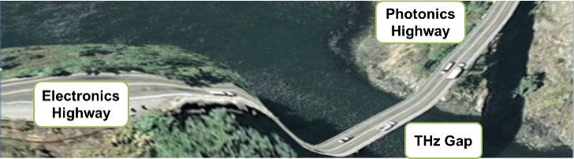
The developed solutions involve components and complete systems for sensing, instrumentation, imaging, spectroscopy and communications. This will be achieved developing novel technologies and co-design of sub-systems and introducing innovative cointegration platforms and new engineered systems. All these technologies are keys to tackling challenges and creating solutions in a large number of focus areas relevant for the societal challenges identified in the Horizon 2020 programme.
Project Facts
CELTA is a European international training network (ITN) project led by Eindhoven University of Technology (TU/e). The project concentrates the efforts of 15 PhDs from 12 partners stemming from 9 different countries. CELTA aims to produce the next generation of researchers who will enable Europe to take a leading role in the multidisciplinary area of utilising Terahertz technology for applications.
Duration:
48 Months: March 2016 – February 2020
Budget:
€3.8 M from the European Commission under the Horizon 2020 programme.
Expected Impact
CELTA aims to provide PhDs with exposure to the range of skills necessary to address the challenge of bringing photonics and electronics together by providing a training on a common engineering language.
Furthermore, our vision is to enable transfer of academic research to industrial application by close collaboration while providing PhDs with a comprehensive understanding of the challenges that industry faces.
Technical research
Photonic Vector Network Analyzer (PVNA)
This demonstrator focuses on developing widely tunable Free-Space Vector Network Analyzer (FS-VNA) operating from 0.05 THz up to 2.7 THz. The design is based on photomixing of two tunable telecom lasers in photoconductive antennas in order to generate and coherently detect a terahertz signal. The inherent wide tunability of the photonically-enabled FS-VNA makes it a very useful tool not only for spectroscopy, but also for material characterization, a fundamental area of research for the development of future terahertz applications.
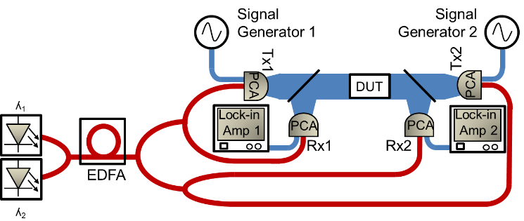
THz Beamformer
In this demonstrator, focused on THz beam steering, the PhDs design and build a transmitter and a receiver capable of:
- Providing higher bitrates for wireless indoor communications operating THz frequencies.
- Using directive antennas to counteracted low achievable power levels and attenuation at THz.
- Improving alignment between devices through beam steering.
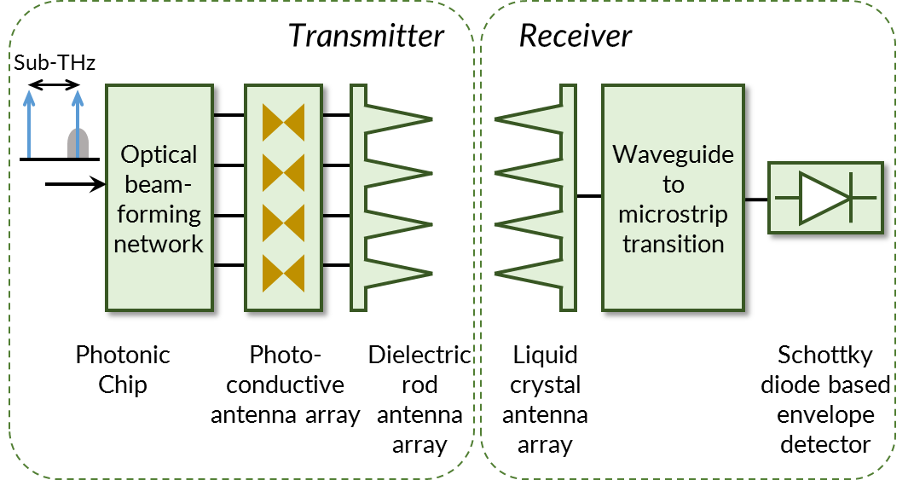
Imaging system
The goal of this demonstrator is to work towards a THz imaging system working 557 GHz. All the shown parts are designed using state-of-the art technologies of different fields: voltage-controlled oscillators, power amplifiers, frequency multipliers, antennae or THz detectors and imaging systems. The system is designed to be used for water absorption-related applications as 557 GHz corresponds to water absorption line. All the developed elements of the imaging system will push the development of THz technology.
